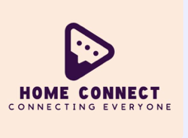
| Home Connect
Central Circular
Communication 1

About Home Connect
Welcome to Home Connect, your dedicated platform designed to foster seamless communication and collaboration between schools and parents. In today's fast-paced world, staying informed and connected is more crucial than ever for a child's educational journey. Home Connect bridges this gap, providing a centralized, intuitive, and secure environment for all your school-related interactions.

Our mission is to empower parents with real-time updates, direct communication channels with educators, and easy access to essential school resources. From academic progress and upcoming events to important announcements and shared documents, Home Connect ensures you're always in the loop, enabling you to actively participate in your child's learning
experience.

We believe that a strong partnership between home and school is fundamental to student success. Home Connect is built on principles of transparency, accessibility, and user-friendliness, making it easier for every parent to engage with their school community. Thank you for being a part of Home Connect – together, we can create a more connected and supportive educational environment.

Our Vision
To create a world where every parent feels fully connected and informed about their child's education, fostering an engaged community that supports lifelong learning.

